**From:** Lee, Jacques   
**Sent:** Thursday, 29 December, 2016 5:11 PM  
**To:** Chan, Pei-Fong; Nathaniel, Agustin  
**Cc:** Soh, Ivy; Wai Keat, Loong  
**Subject:** IBMSND WMS --> Outbound --> PickList (Adjust Margin on IBM Order#)

Hi Pei Fong/ Nathaniel,

Good Day.

Can please help to adjust wider on barcode at IBMSND WMS Outbound → Picklist?

We not able to do scan pack on IBM order#.

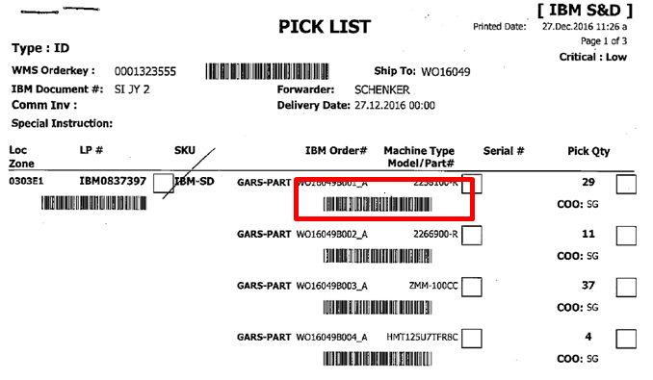

Kind regards,

Lee Jacques (Mr)

Contract Logistics/SCM

Schenker Singapore (Pte) Ltd

2 Changi South Street 2,

#01-01 SLC1

Singapore 486759

Phone: +65 6549 1237/ 9716 8905

Email: [jacques.lee@dbschenker.com](mailto:jacques.lee@dbschenker.com)

Global website [www.dbschenker.com](http://www.dbschenker.com)